1. **Get Users**: <http://localhost:8080/JerseyDemo/webapi/users/getusers>

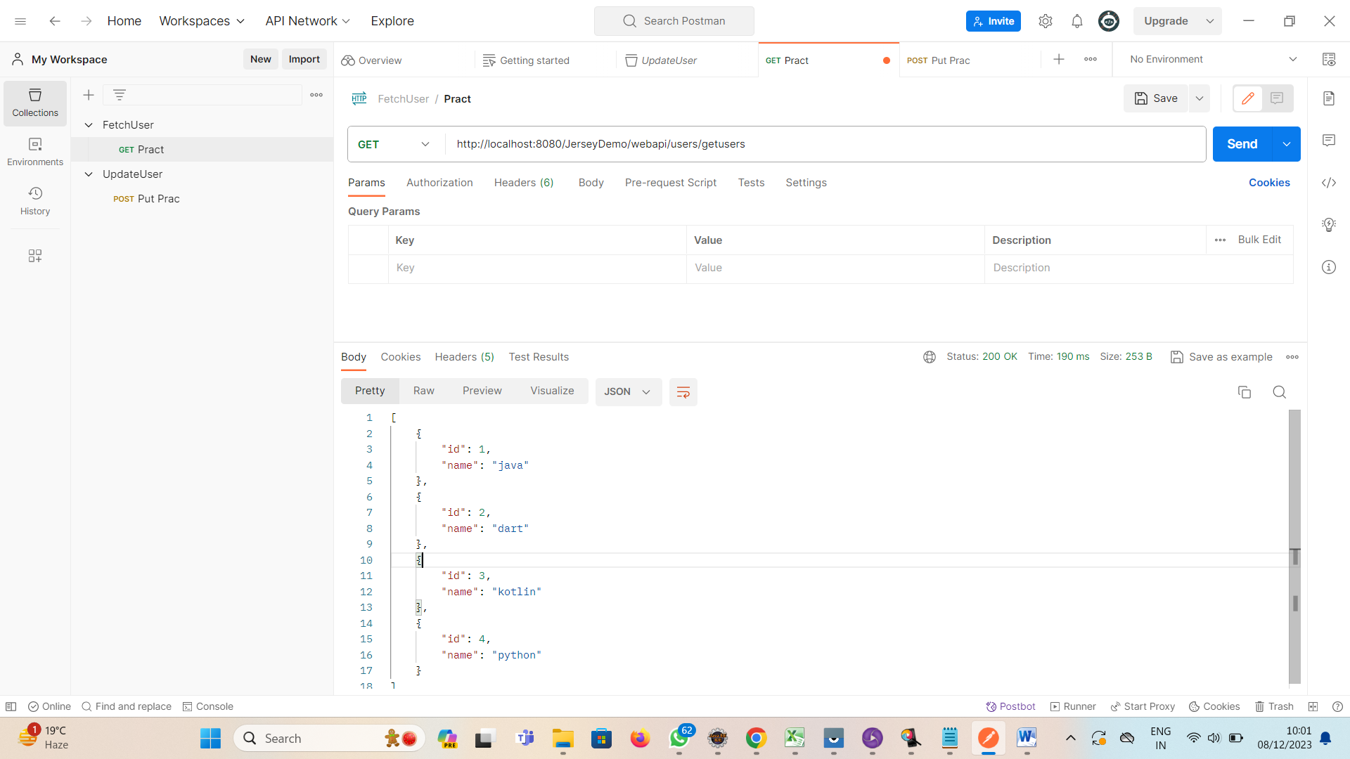

1. **Get User With Single ID:** <http://localhost:8080/JerseyDemo/webapi/users/getusers/3>

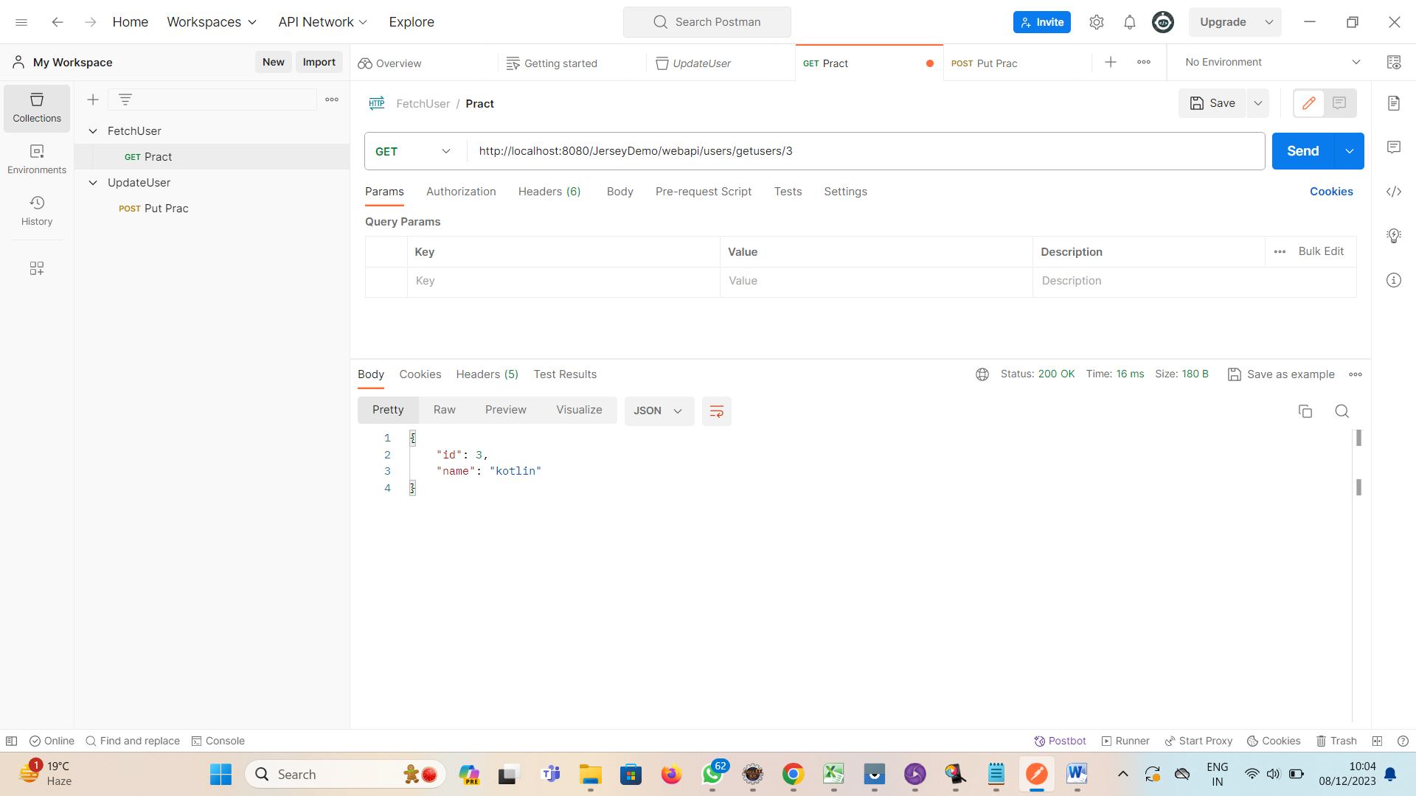

1. **POST USER:** <http://localhost:8080/JerseyDemo/webapi/users/adduser>

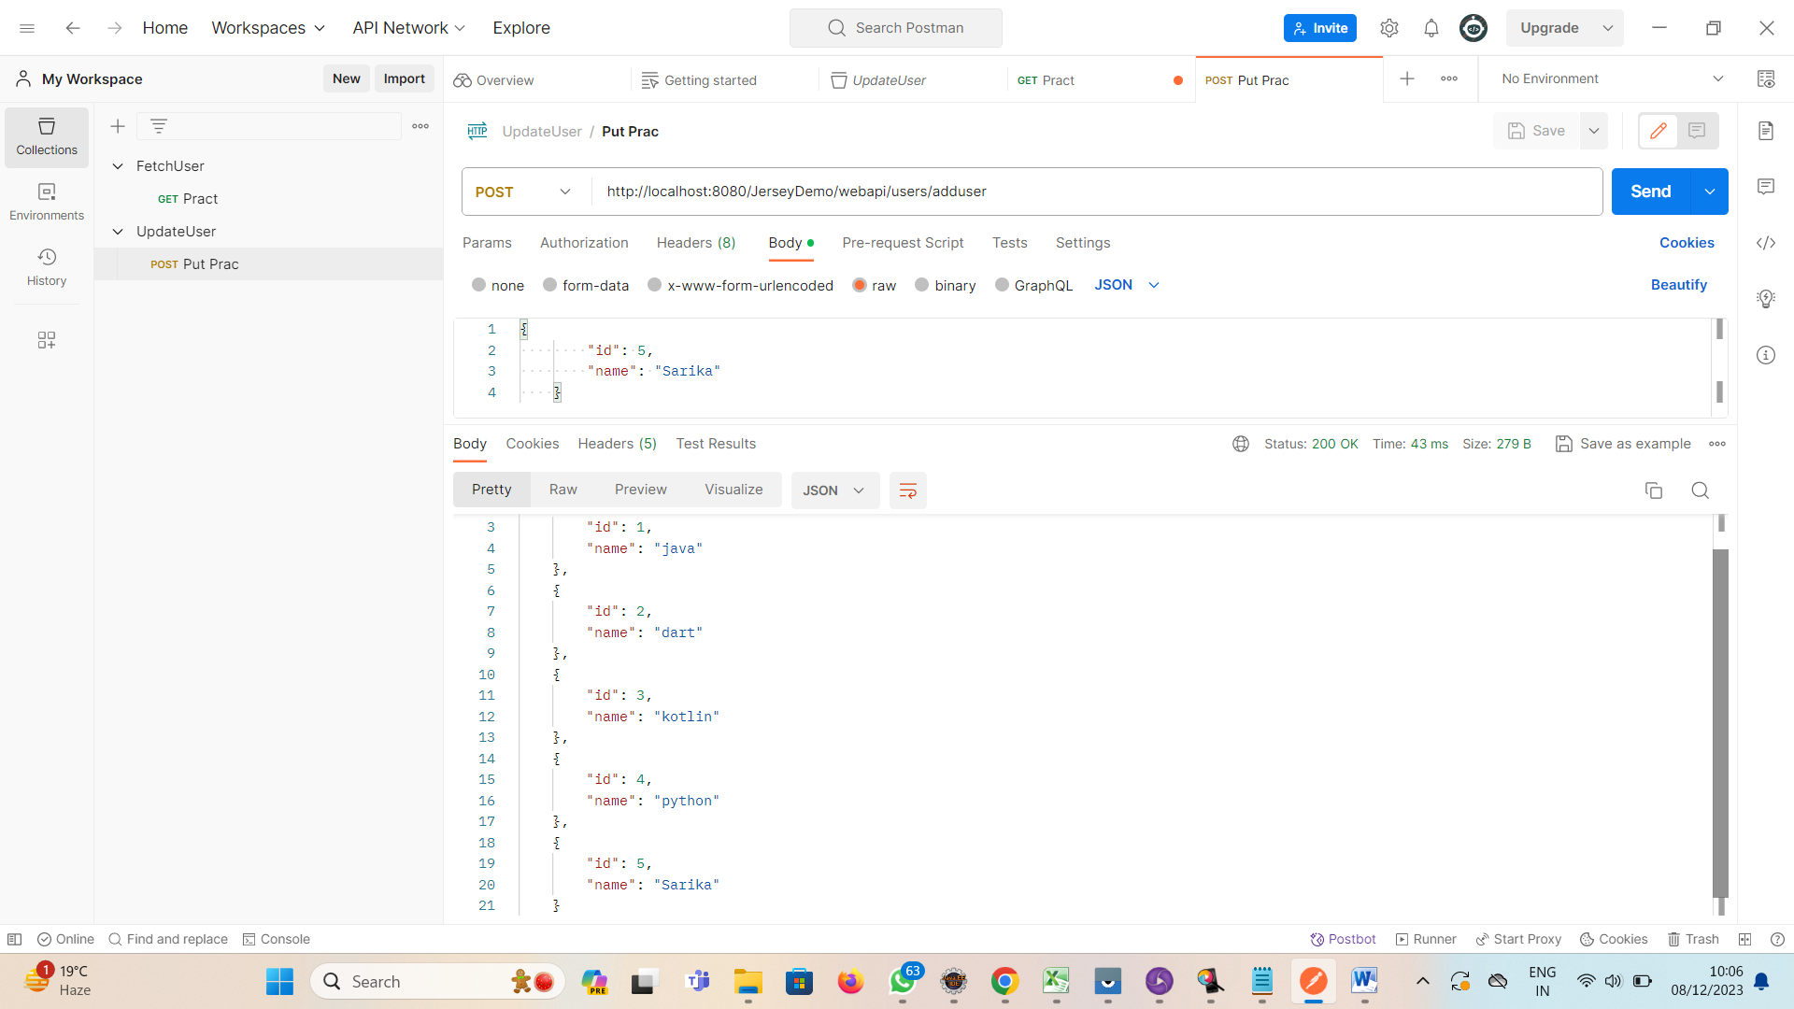

**4.DELETE USER:** <http://localhost:8080/JerseyDemo/webapi/users/deleteuser/4>

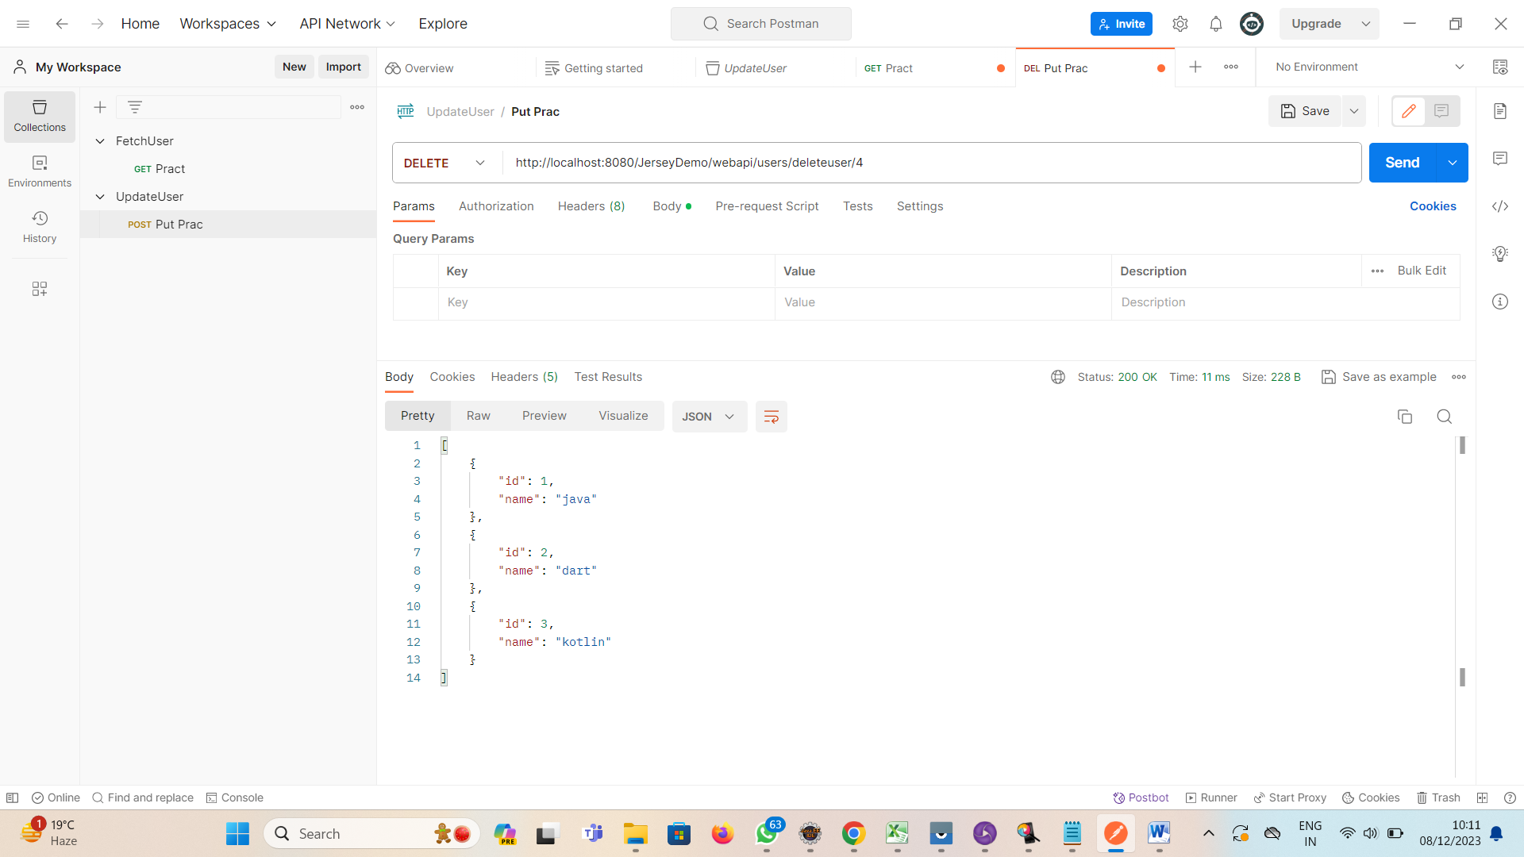

**5.PUT USER:** <http://localhost:8080/JerseyDemo/webapi/users/2>

